**Submission Requirements:**

1. Submit links to the original and forked repositories.
2. Include a screenshot of the branches created by each partner.

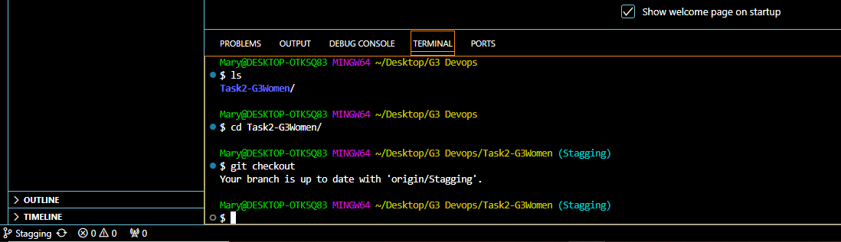

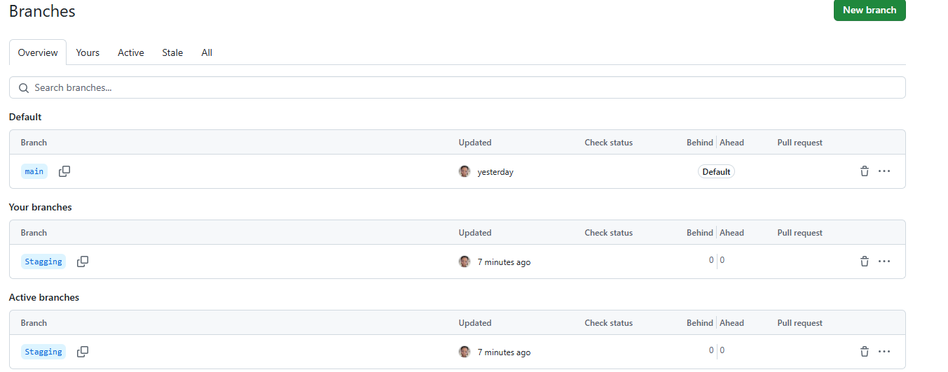

1. Submit the markdown file with your Learnings from Week 1.
2. Submit a screenshot showing commit history with at least 3 commits from each partner.
3. Provide links to each partner’s pull request, and include a screenshot of the review comments.
4. Submit the final link to the repository with both partners' reflections merged, along with the final commit history.